**EXPERINMENT 9**

**Aim :** Apply Different filter on Fourier transform of image and convert back to spatial domain.

* **Exercises :**

1. **Ideal low pass filter.**

Code :

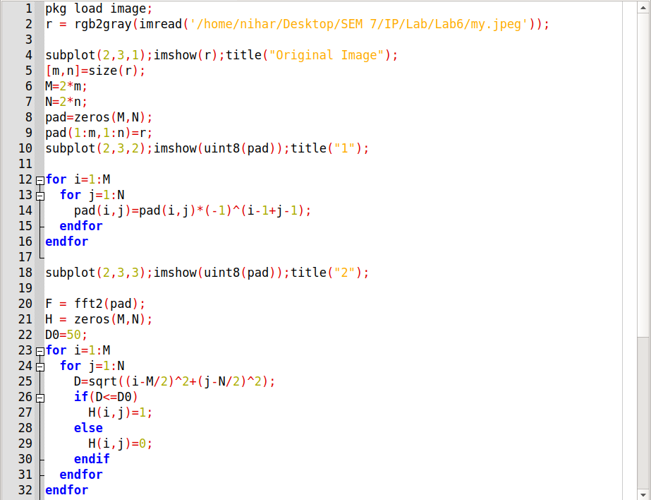

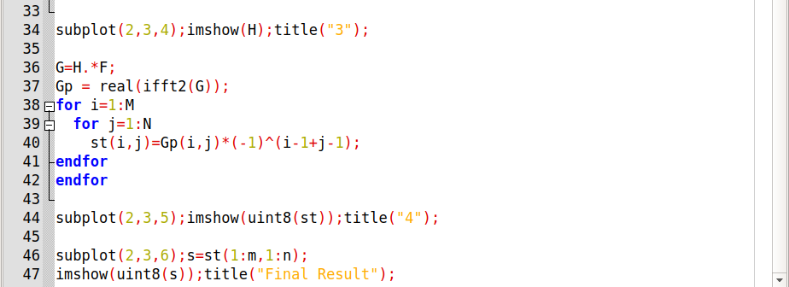

Output :

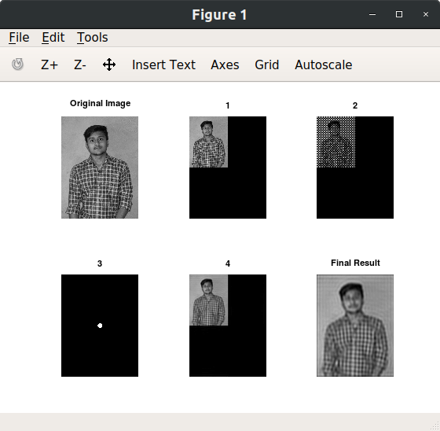

1. **Ideal high pass filter.**

Code :

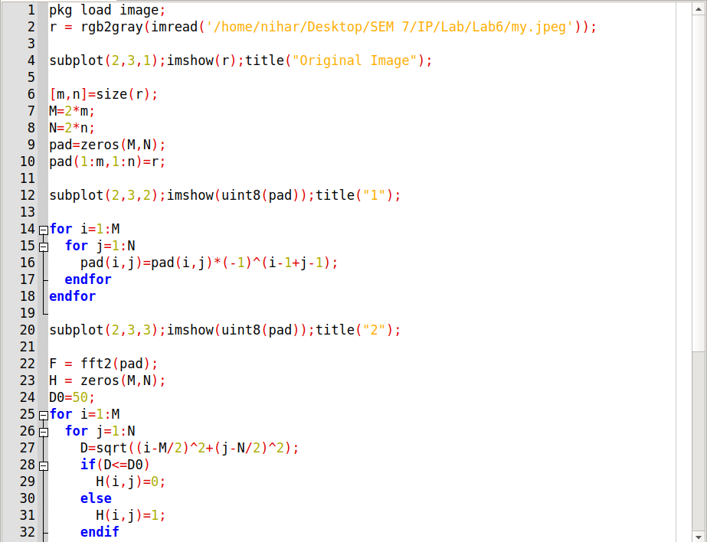

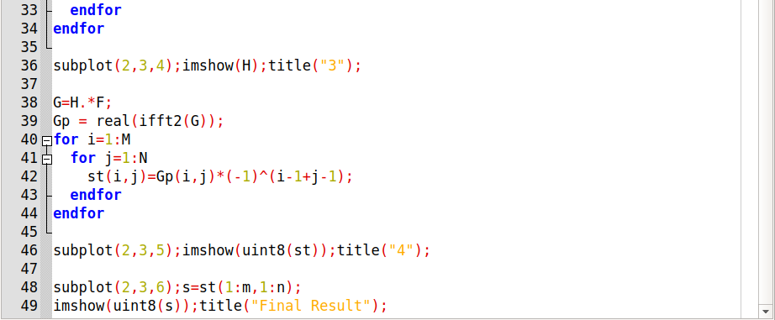

Output :

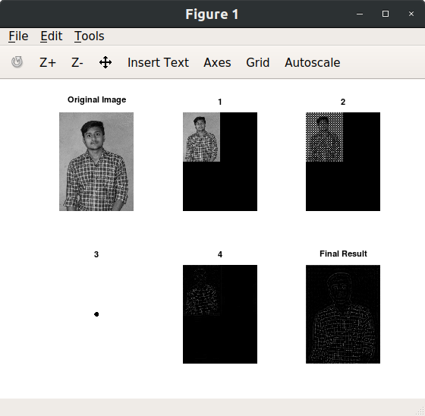

1. **Ideal band pass filter.**

Code :

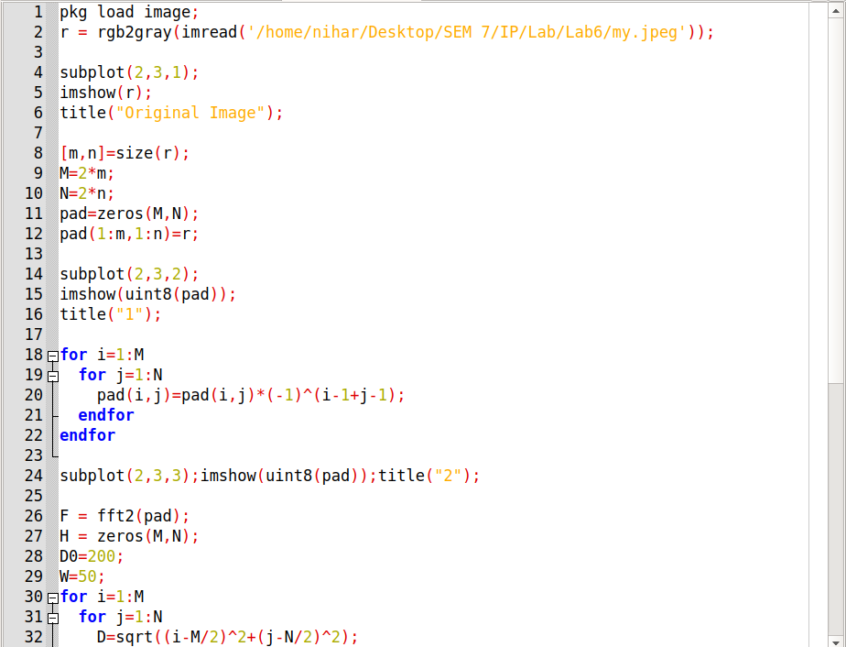

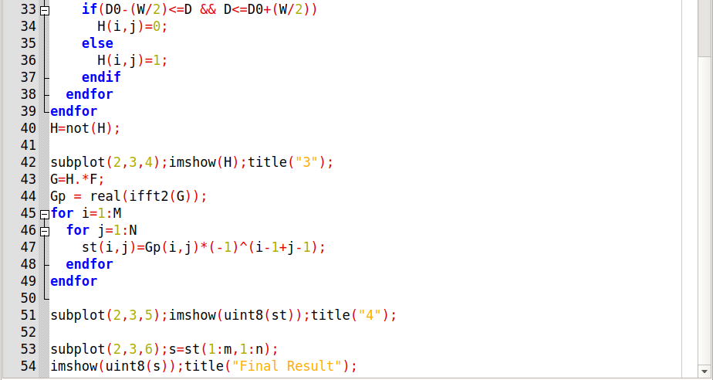

Output :

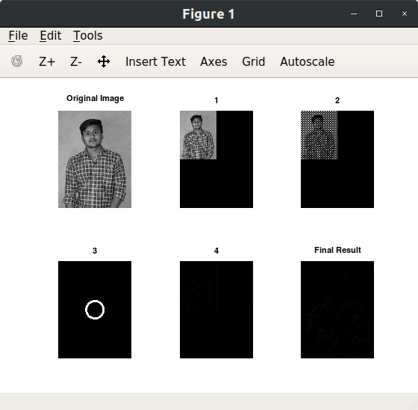

1. **Guassian High Pass filter.**

Code :

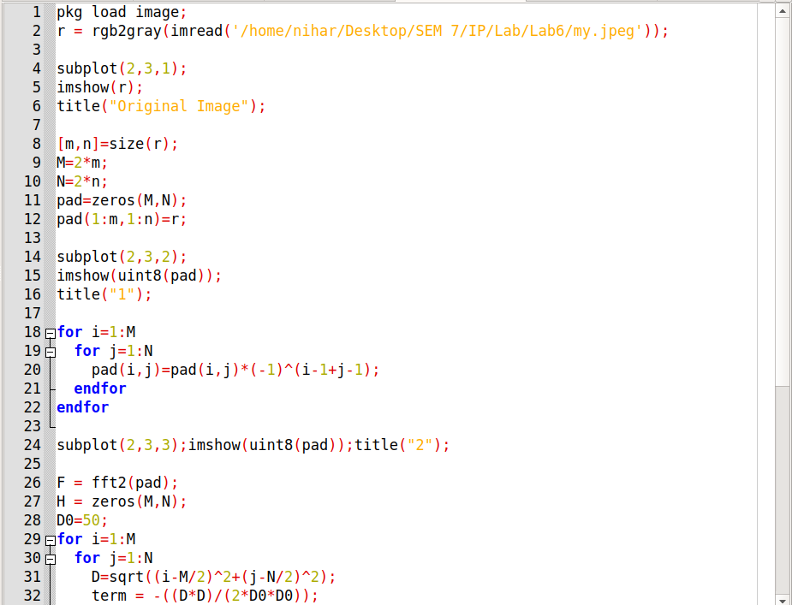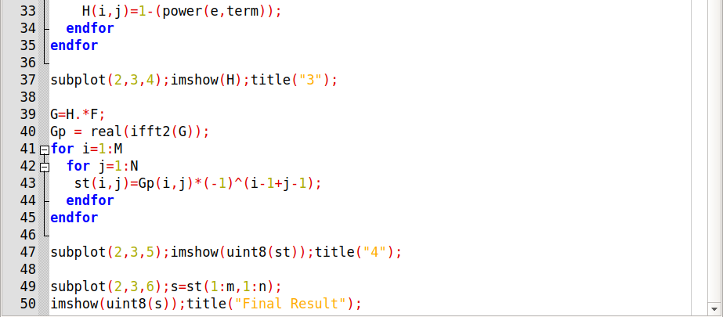

Output :

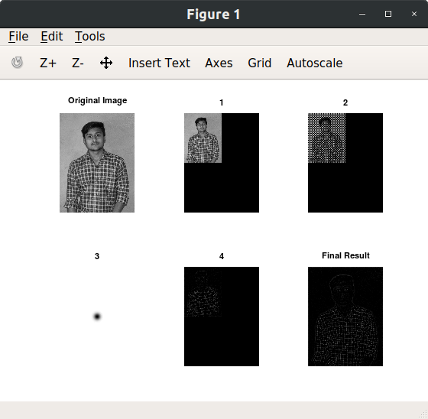

1. **Guassian Low pass filter.**

Code :

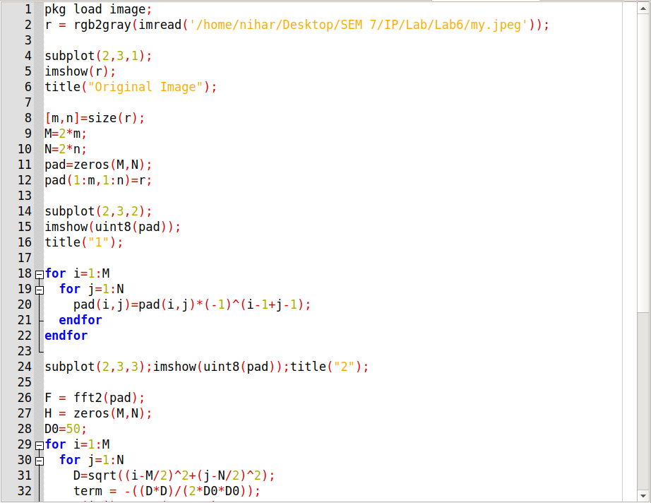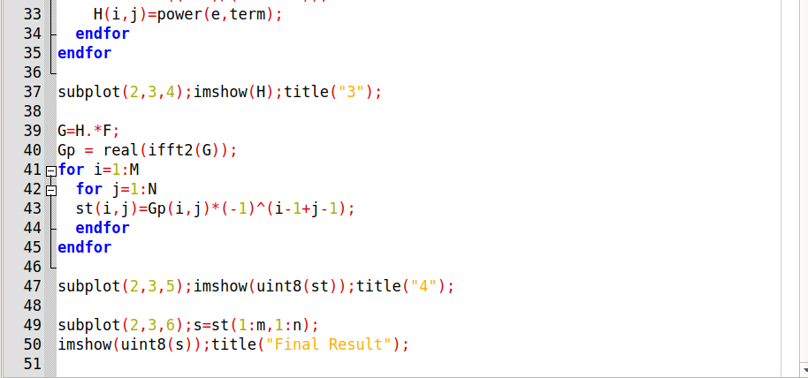

Output :

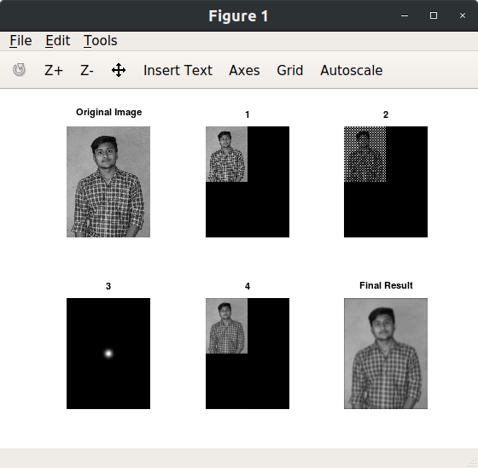

1. **Gaussian band reject filter.**

Code :

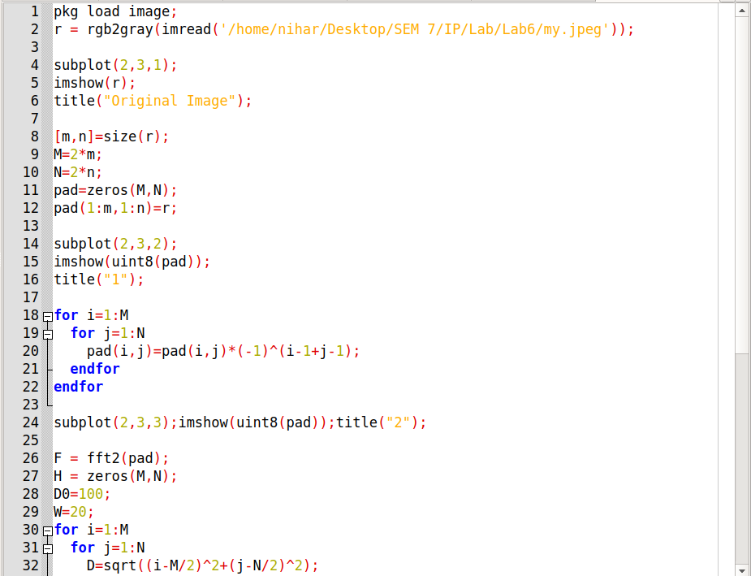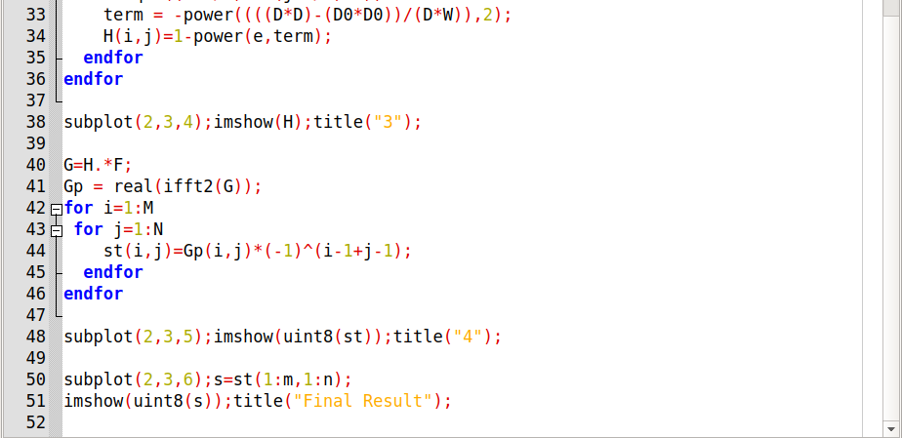

Output :

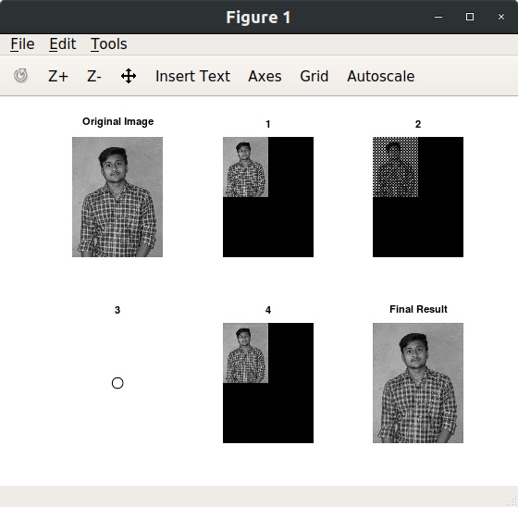

1. **Butterworth low pass filter.**

Code :

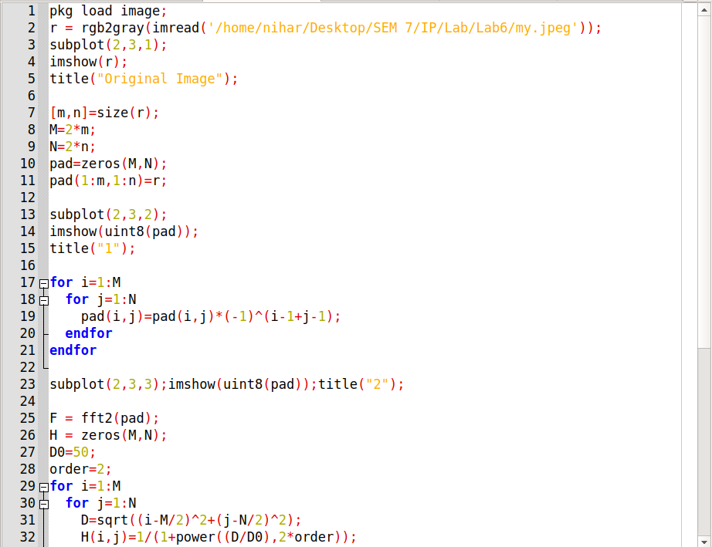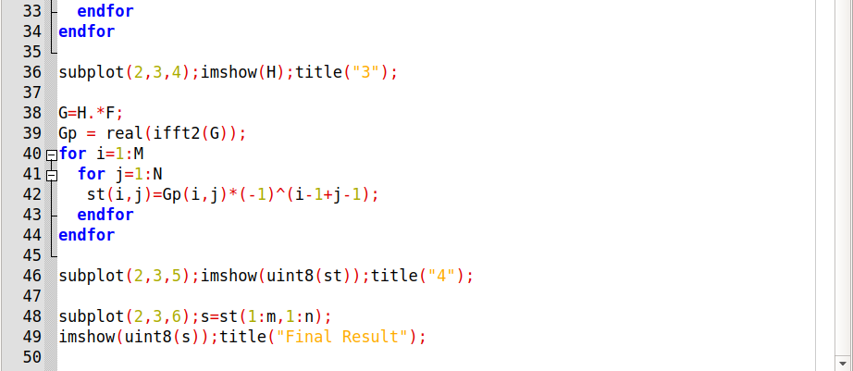

Output :

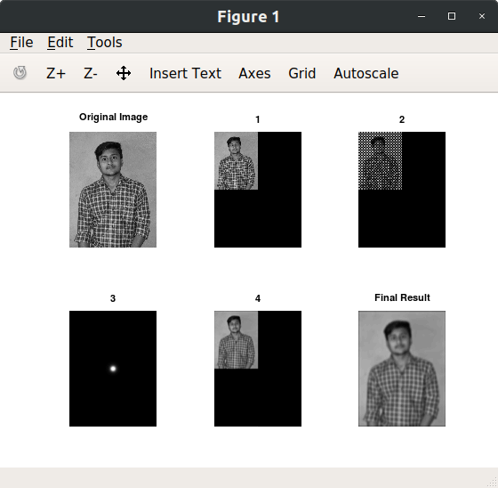

1. **Butterworth high pass filter.**

Code :

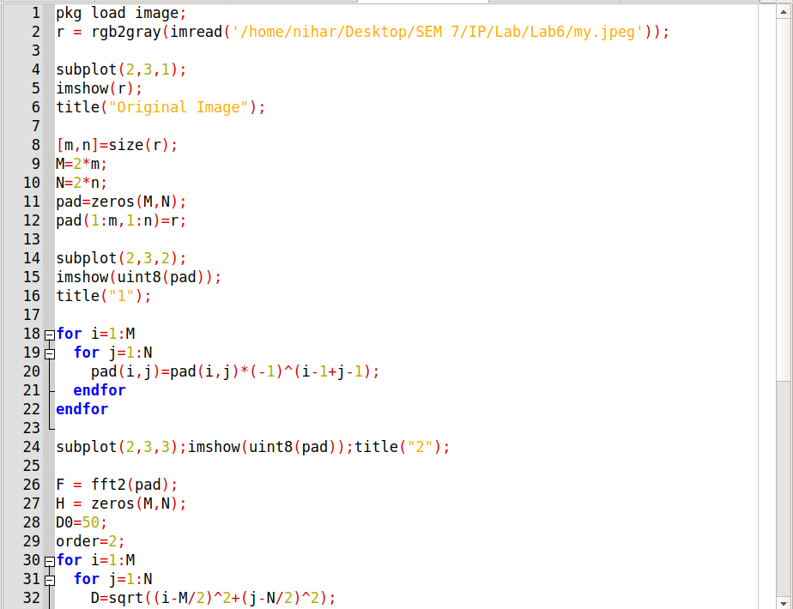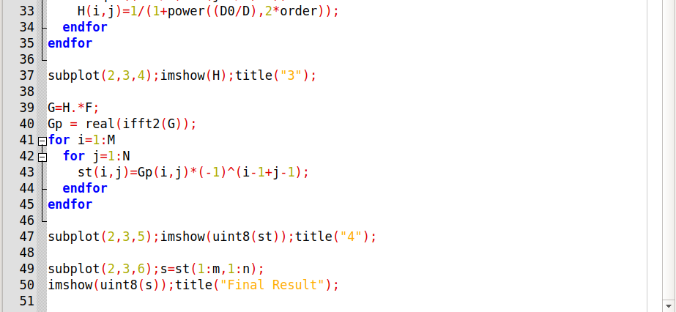

Output :

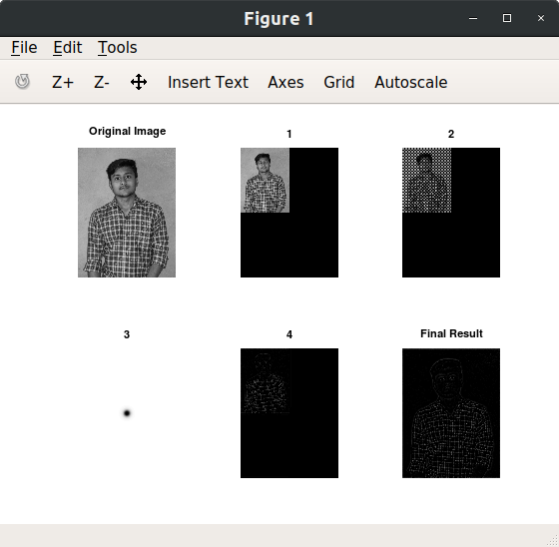

1. **Notch pass filter.**

Code :

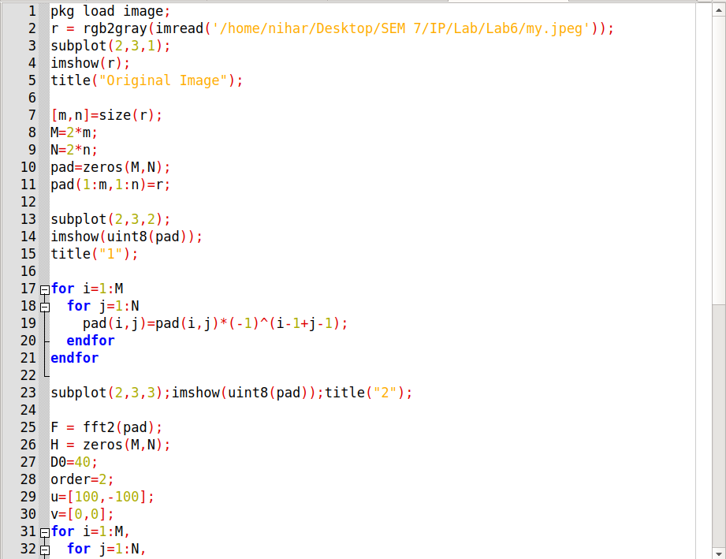

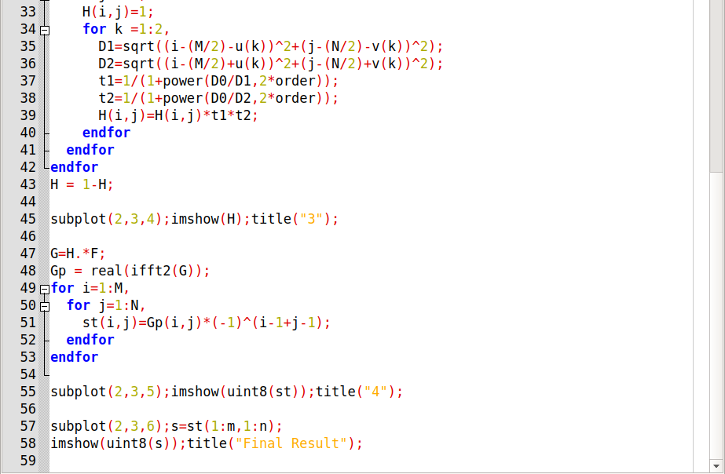

Output :

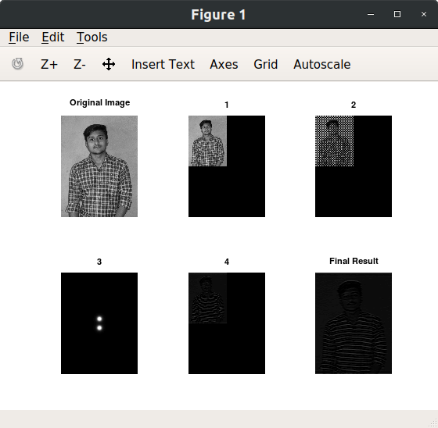

1. **Notch reject filter.**

Code :

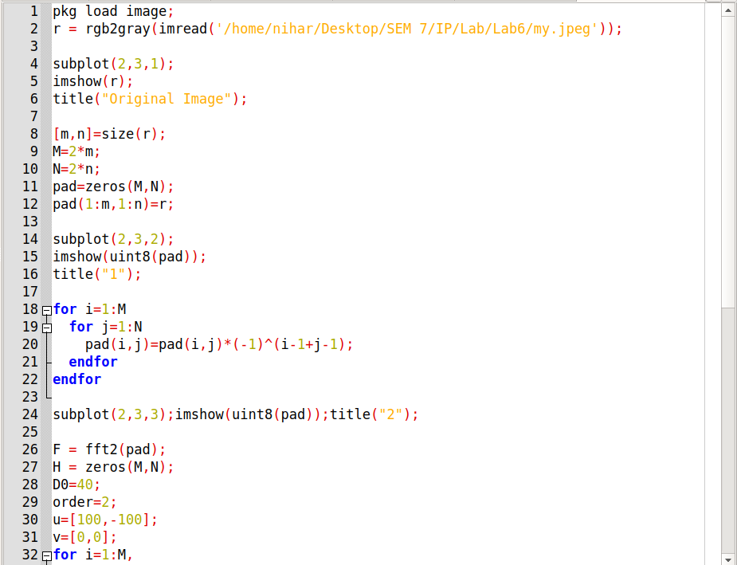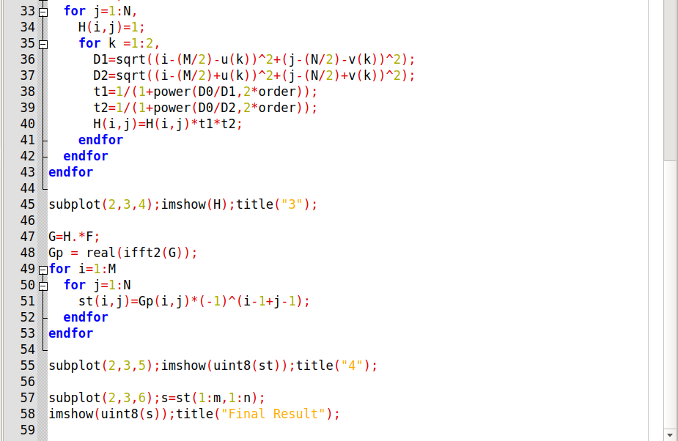

Output :

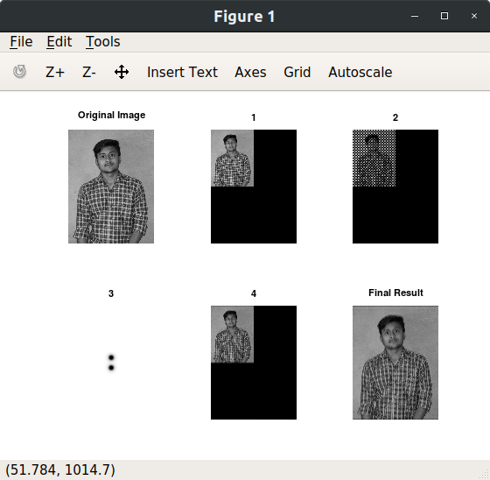

* **Final Conclusion :**

For Ideal Low Pass Filter:

* Blurring effect which decreases as the cutoff frequency increases.
* Ringing effect which also decreases as the cutoff frequency increases.

For Ideal High Pass Filter:

* Ringing effect.
* Edge distortion (i.e. distorted, thickened object boundaries).
* Both effects are decreased as the cutoff frequency increases.

For Gaussian Low Pass Filter:

* Smooth transition in blurring as a function of increasing cutoff frequency.
* No ringing effect.

For Gaussian High Pass Filter:

* No ringing effect.
* Less edge distortion.
* The results are smoother than those obtained by IHPF.

For Butterworth Low Pass Filter:

* Smooth transition in blurring as a function of increasing cutoff frequency.
* Ringing effect in the BLPF becomes significant as the nth order increases.

For Butterworth High Pass Filter:

* Results are much smoother than obtained with an IHPF.